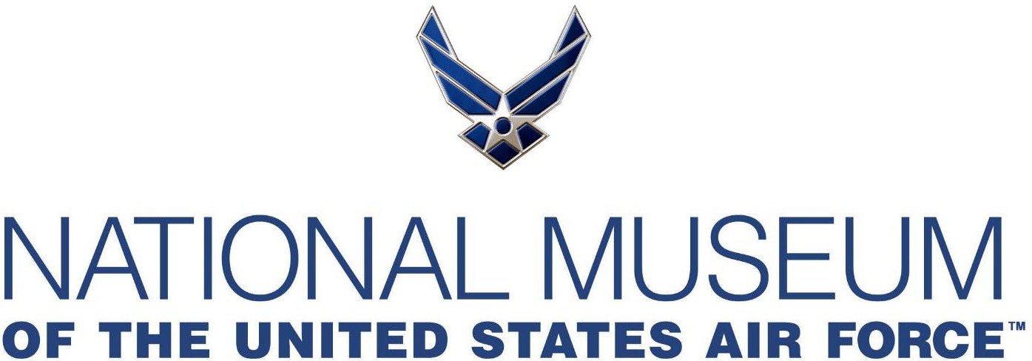

Memorial Park Program: Information Guide
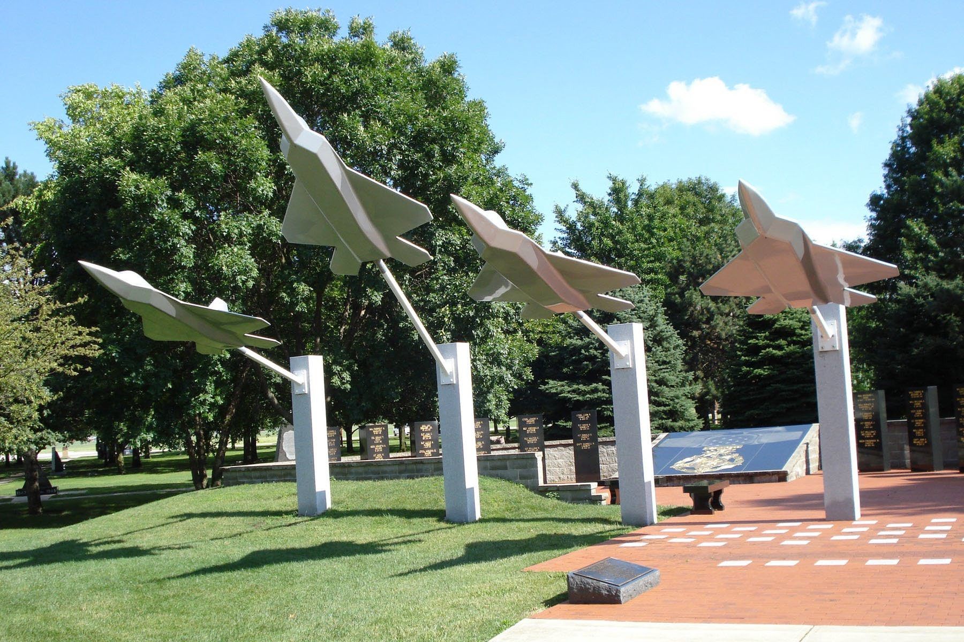
Memorial Park Manager Contact Information:

NMUSAF/MUS - Memorial Park Manager 1100 Spaatz Street
Wright-Patterson AFB, OH 45433
Email: nationalmuseum.mus@us.af.mil Phone: 937-255-1743

National Museum of the U.S. Air Force™ Memorial Park Program: Information Guide

Welcome & Program Overview
The Memorial Park at the National Museum of the United States Air Force™ (NMUSAF) was established in 1971 to honor individuals, units, and groups for their contributions to the Department of the Air Force and Army Air Forces. Today, the park holds over 700 memorials dedicated to the legacy and service of Airmen past and present. This guide outlines the complete process for submitting, designing, and installing a memorial in the park. Whether you represent a veterans association, military unit, or a family honoring a loved one, our Memorial Park Manager is here to help you every step of the way.

To view existing memorials currently placed in Memorial Park, visit:
� https://www.nationalmuseum.af.mil/Visit/Museum-Exhibits/Memorial-Park/ Reviewing existing memorials may help with formatting ideas and ensure your memorial represents something not already commemorated.

Step-by-Step Submission Process:

STEP 1: Submit a Complete Memorial Package
Submit all of the following together as one package to the Memorial Park Manager:
- Letter of Intent (Attachment 1)
  - Must be on official letterhead
  - Signed by an authorized representative
  - Include:
    - Point of contact name, address, phone, and email
    - Conﬁrmation that funds are available
    - Memorial type requested
    - Relationship to the U.S. Air Force or Army Air Forces

Memorial Design digital proof
  - Complete draft including all wording, images, and emblems
  - Must clearly honor service to the Department of the Air Force

Vendor Quote and Speciﬁcations
  - Total cost for memorial and installation
  - Engineering drawings with full dimensions and weight
  - Foundation design for large memorials (if applicable)

  - Contractor name, contact, and estimated completion date
- Signed Offer of Gift (Attachment 2 for organizations / Attachment 3 for individuals)
  - Transfers ownership of the memorial to the NMUSAF
  - Clearly state that the gift in question is “conditional,” the condition being that the memorial will be installed in the NMUSAF’s Memorial Park.

STEP 2: Museum Review and Approval
- The Memorial Park Manager will review letter of intent, design, digital proof, vendor quote,
speciﬁcations, and the signed offer of gift.
- You will receive:
  - Letter of Acceptance (if approved), or
  - Letter of Declination with guidance

STEP 3: Submit Perpetual Care Donation (Attachment 4)
Within 30 days of receiving Letter of Acceptance, submit perpetual care donation.
- Donation Amount: 20% of total memorial cost
  - Example: $10,000 memorial = $2,000 donation
- Make checks/money orders payable to: Air Force Museum Foundation
- Memo Line: Memorial Park Perpetual Care – [Donor Last Name]
- Mail to: Air Force Museum Foundation PO Box 33624
WPAFB, OH 45433
- OR Credit Card Payment to: https://airforcemuseumfoundation.org/memorialparkpayment/
Note: This is a restricted donation that helps offset long term real property maintenance costs of Memorial Park. Perpetual care funds only cover damage from acts of nature or vandalism. It does not cover design changes, cosmetic upgrades, or enhancements.

STEP 4: Schedule Delivery and Installation
- Coordinate with contractor and Memorial Park Manager
- Comply with NMUSAF safety guidelines
- Foundation plans must be approved by WPAFB Civil Engineering

STEP 5: Plan a Dedication Ceremony (Optional)
- Work with Memorial Park Manager to schedule
- Ceremonies requiring Museum/base support must occur:
  - Monday–Friday, 9:30 AM to 2:00 PM

Memorial Options and Speciﬁcations:
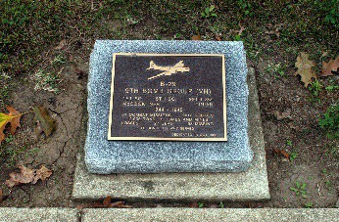
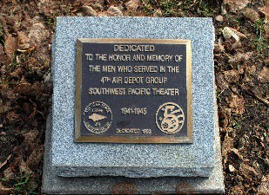
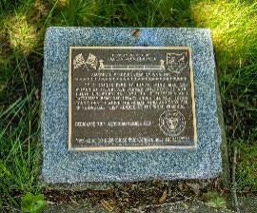
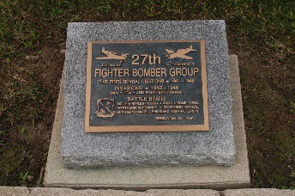

- Granite Marker with Bronze Plaque: Granite Markers are placed low on the ground along the sidewalk with the bronze ground plaque seated on top.
  - Granite: 16” x 14” x 6” (with 4” drop, 2” nose)
    - Must be affixed with epoxy and four anchor bolts to foundation
  - Foundation: 24” x 24” x 24” solid concrete (if required)
  - Bronze Plaque: 12” long by 10” high and 1/2” thick (5/8” including lettering).
    - All bronze plaques must have a bevel border 9/16” wide.
    - The mineral content of the bronze plaque shall be no less than 87% copper, 4.5% tin, 2% lead, and 4% zinc with the balance being other inert materials.
    - Plaques must be clear coated and guaranteed to withstand oxidation for approximately ten years.
    - The color will be Medium/Dark Brown, and the font must be News Gothic Bold.
    - Must be affixed with epoxy and four anchor bolts to the granite
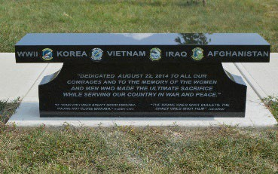
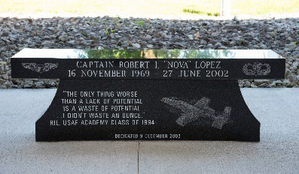
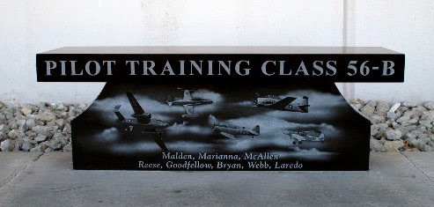

- Granite Memorial Bench: Granite Memorial Benches may be placed in Memorial Park along the sidewalk or as part of a monument already in place.
  - Seat: 54” x 14” x 4”
  - Legs: 46” x 8” x 14”
  - Foundation: 60” x 18” x 24” (if required)
  - All exposed surfaces must be polished (except bottom of seat)
  - Bench sections must be pinned/anchored together
  - Approved granite types: Barre Gray, American Black, Impala Black, India Black, Asian Granite

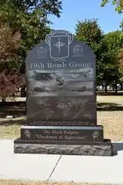
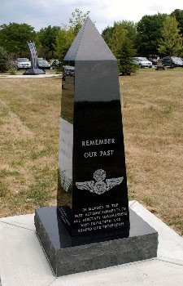
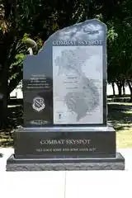
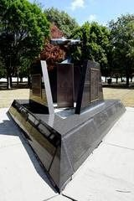
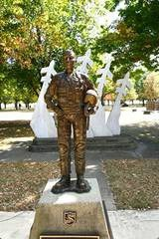
- Large Memorials: Memorial Park can accommodate larger memorials. The cost of large memorials varies based on size, design, and material used. Larger memorials require special approval and handling. Groups inquiring about large memorials should work closely with the Memorial Park Manager for rules and requirements.
  - Site clearance from WPAFB CE required 30 days prior to foundation work
  - If not constructed within 30 days, the site must be re-cleared
  - Memorials ≤ $100K: Approved by NMUSAF Director
  - Memorials > $100K: Require Secretary of the Air Force approval

Note: Due to space limitations, each organization may dedicate only one memorial per individual, unit, campaign, or mission. Final site placement will be determined collaboratively by the Memorial Park Manager and the donor group’s representative.

Design Standards and Additional Information:

  - Only official USAF emblems (AFHRA-approved) may be used
  - Aircraft images must reﬂect actual aircraft used by honoree/unit during its time of service.
  - No promotional websites or QR codes
  - Minimal religious content allowed, subject to Museum Director approval. Content must not be so predominant as to appear to be a religious memorial, rather than a memorial dedicated in honor of a group or individual.
  - Individual memorials must be supported by military service records obtained from the National Personnel Records Service verifying the individual was a member of the USAF.
  - Digital proof must be submitted and approved before casting
  - WPAFB CE must review and approve concrete foundation plans for large memorials
  - All contractor guarantees are between the donor and the contractor
  - Donating organizations and/or individuals are responsible for handling all arrangements and payment of bills.
  - Museum is not responsible for contractor errors or performance

Fiscal Agent Support (Optional)
If you are interested in learning about using a ﬁscal agent for your organization’s memorial,
contact:

Executive Director
National Aviation Heritage Alliance Email: mdw@aviationheritagearea.org Phone: 937-626-8816

Memorial Park Manager Contact Information:
Please schedule an appointment before visiting or submitting any materials in person.

NMUSAF/MUS - Memorial Park Manager 1100 Spaatz Street
Wright-Patterson AFB, OH 45433
Email: nationalmuseum.mus@us.af.mil Phone: 937-255-1743

Attachments:
  - Attachment 1: Sample Letter of Intent Template
  - Attachment 2: Sample Offer of Gift (Organization)
  - Attachment 3: Sample Offer of Gift (Individual)

Attachment 1: Letter of Intent

NMUSAF/MUS
Memorial Park Manager

SAMPLE LETTER OF INTENT
{LETTERHEAD}

Date

National Museum of the U.S. Air Force 1100 Spaatz St.
Wright-Patterson AFB, OH 45433-7102 Dear,
It is the intention of the (organization name) to place a (plaque, large memorial, or bench) in Memorial Park at the National Museum of the United States Air Force.

(Include details and background information HERE of the memorial that can be included with the final package for review)

The (organization name) has received the Memorial Park information packet and understands the policies and procedures for placing a memorial at the Museum.

(Memorial manufacturer name) has been chosen by (organization name) to produce the memorial once final approval has been granted by the Museum. The (organization name) also has sufficient funds to place the memorial and contribute the specified amount to the memorial’s perpetual care. We understand that it is our responsibility to do a rubbing of the memorial prior to manufacture.

(Point of contact name) has been appointed by (organization name) to coordinate the memorial placement process with the NMUSAF Memorial Park Manager. If at any time, the point of contact changes, the group understands the change must be submitted in writing.

Contact information for (organization name) is:
Full name Address Phone number E-mail

Sincerely, (Officer of group)

(Person who sends this letter must not name him/herself as the point of contact. It must come from another individual, preferably an officer, of the group naming the point of contact.)

Attachment 2: Offer of Conditional Gift (Organization)

SAMPLE OFFER OF GIFT

KNOW ALL MEN BY THESE PRESENTS:

That the (Name of Organization), a corporation, the owner of the property listed below, acting by and through (Name of Organization Authorized Representative Signing), does hereby voluntarily offer to, transfer, convey, and assign said property, free and clear of all encumbrances, to the Secretary of the Air Force, acting on behalf of the United States of America, to have and to hold the same forever, relinquishing upon such gift and conveyance for itself, its successors and assigns all ownership, rights, title, interest and possession therein to the donee absolutely: (Description of Property). Pursuant to this offer, I will deliver to the Department of the Air Force a deed transferring valid title to said property to the Secretary of the Air Force, acting on behalf of the United States of America.

The gift and conveyance of said property offered herein does not entail the granting by the donee of special concessions or privileges to the donor.

The gift and conveyance of said property offered herein is made for the benefit of or use in connection with the establishment, operation, or maintenance of the National Museum of the United States Air Force, or other institution or organization under the jurisdiction of the Department of the Air Force, in conformance with 10 U.S.C. § 2601.

IN WITNESS WHEREOF the (Name of Organization) has affixed its seal and caused this instrument to be executed by (Name of Organization Authorized Representative Signing for and on behalf of the (Name of Organization) this

(Day) of (Month) (Year).

(Name of Organization) By (Signature)

CERTIFICATE

I, (Name of Other Authorized Representative of the Organization), certify that I am the (Title), of the (Name of Organization), a corporation; that (Name of Organization Authorized Representative), who signed this Offer of Gift, dated (Date), on behalf of the (Name of Organization), is the (Title of Organization Authorized Representative Signing) of the (Name of Organization); and that said Offer of Gift was duly signed for and on behalf of said corporation by authority of its governing body and is within the scope of its corporate powers.
(Date) (Name)

(Corporate Seal)

Attachment 3: Offer of Conditional Gift (Individual)

SAMPLE OFFER OF GIFT

KNOW ALL MEN BY THESE PRESENTS:

That I, (Name), the owner of the property listed below, do hereby voluntarily offer to, transfer, convey, and assign said property, free and clear of all encumbrances, to the Secretary of the Air Force, acting on behalf of the United States of America, to have and to hold the same forever, hereby relinquishing for myself, my executors, administrators, heirs and assigns all ownership, rights, title, interest and possession therein to the donee absolutely: (Description of Property). Pursuant to this offer, I will deliver to the Department of the Air Force a deed transferring valid title to said property to the Secretary of the Air Force, acting on behalf of the United States of America.

The gift and conveyance of said property offered herein does not entail the granting by the donee of special concessions or privileges to me or my executors, administrators, heirs and assigns.

The gift and conveyance of said property offered herein is made for the benefit of, or use in connection with, the establishment, operation, or maintenance of the National Museum of the United States Air Force, or other institution or organization under the jurisdiction of the Department of the Air Force, in conformance with 10 U.S.C. § 2601.

(Signature) (Seal) (Dated)
WITNESS:

(Signature)

